Assignment 4 Submission
Automatic EBS Snapshot and Cleanup Using AWS Lambda and Boto3

1. Objective
The objective of this assignment is to automate the backup process for Amazon EBS volumes using AWS Lambda and Boto3, and to automatically delete snapshots older than 30 days to optimize storage usage and reduce cost.

2. AWS Services Used
- Amazon EC2
- Amazon Elastic Block Store (EBS)
- AWS Lambda
- AWS Identity and Access Management (IAM)
- Amazon EventBridge / CloudWatch Events
- Amazon CloudWatch Logs
- Boto3 (AWS SDK for Python)

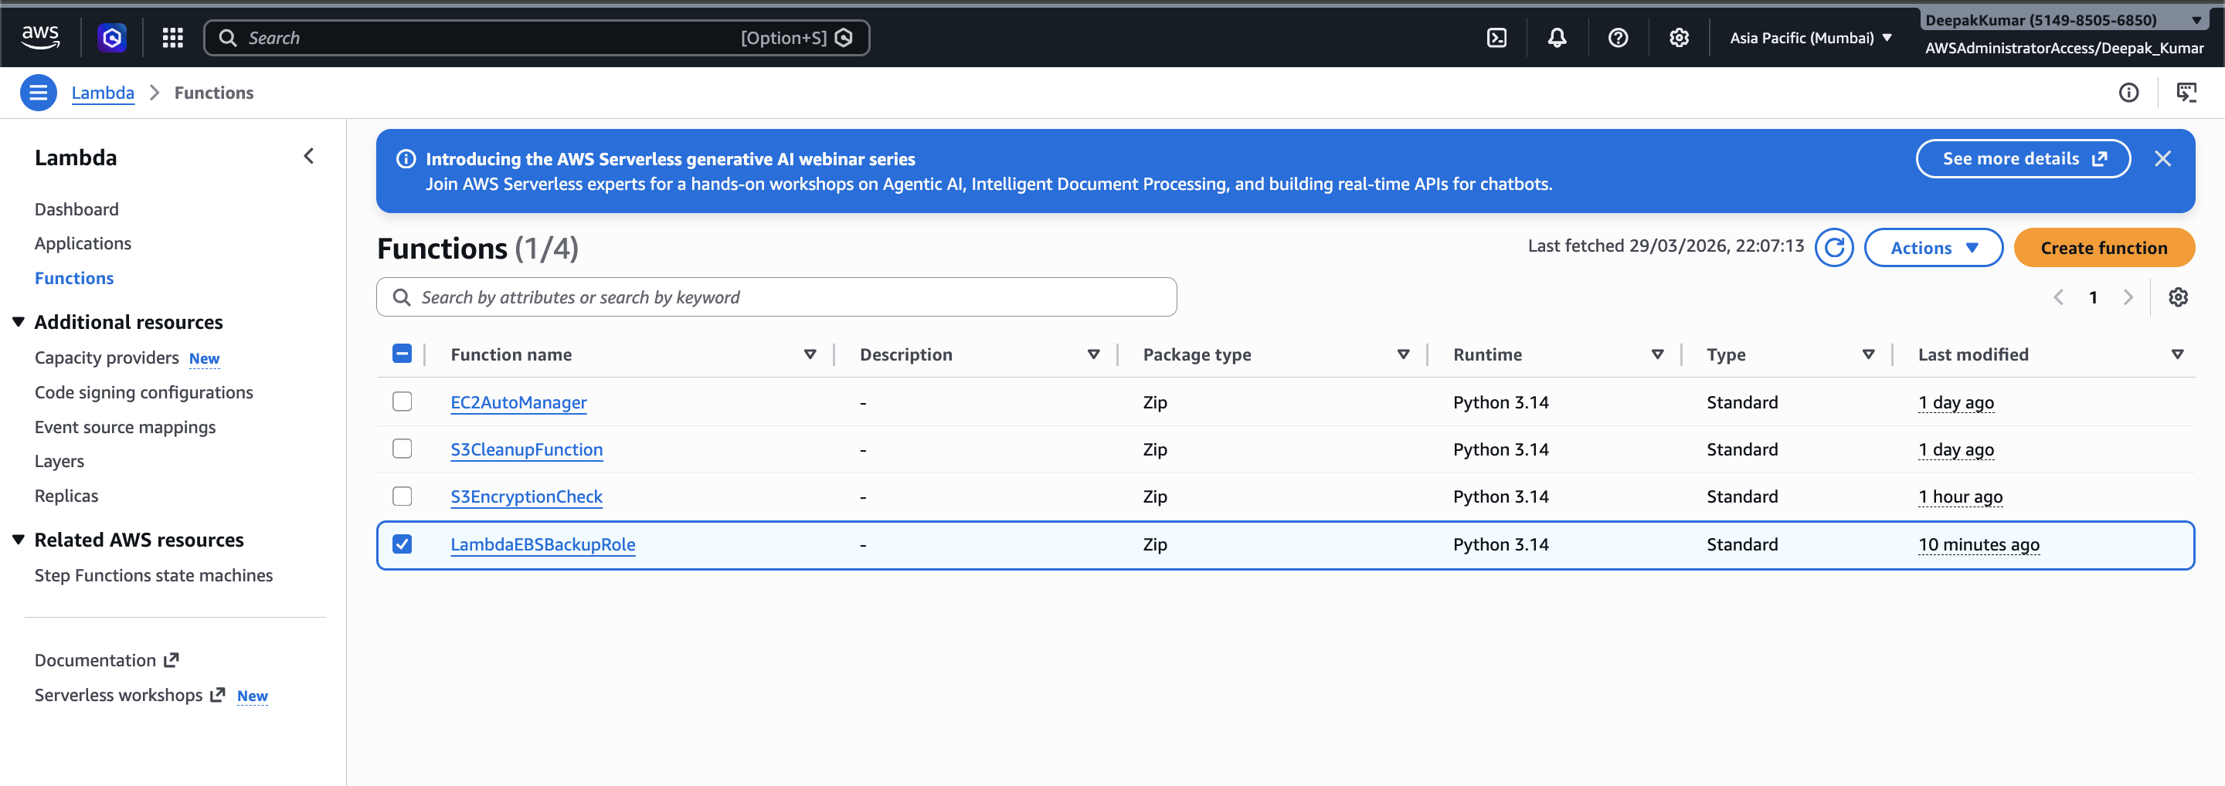

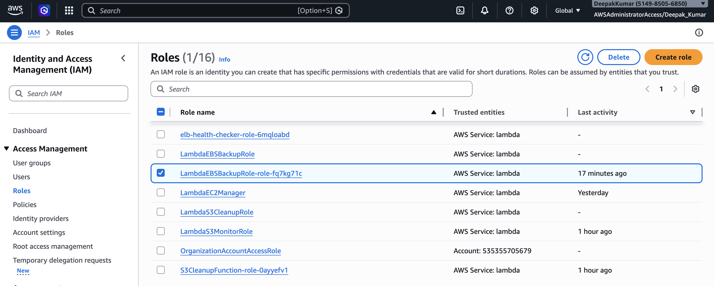

3. Python Code
import boto3
from datetime import datetime, timedelta, timezone
ec2 = boto3.client('ec2')
VOLUME_ID = 'vol-xxxxxxxxxxxxxxxxx' # Replace with your EBS volume ID
RETENTION_DAYS = 30
def lambda_handler(event, context):
created_snapshot_id = None
deleted_snapshots = []
# Create snapshot
response = ec2.create_snapshot(
VolumeId=VOLUME_ID,
Description=f"Automated snapshot for {VOLUME_ID}"
)
created_snapshot_id = response['SnapshotId']
print(f"Created snapshot: {created_snapshot_id}")
# Calculate retention date
cutoff_date = datetime.now(timezone.utc) - timedelta(days=RETENTION_DAYS)
# Fetch snapshots owned by you
snapshots = ec2.describe_snapshots(
OwnerIds=['self'],
Filters=[
{'Name': 'volume-id', 'Values': [VOLUME_ID]}
]
)['Snapshots']
for snapshot in snapshots:
if snapshot['StartTime'] < cutoff_date:
ec2.delete_snapshot(SnapshotId=snapshot['SnapshotId'])
deleted_snapshots.append(snapshot['SnapshotId'])
if deleted_snapshots:
print(f"Deleted old snapshots: {deleted_snapshots}")
else:
print("No old snapshots found for deletion.")
return {
'statusCode': 200,
'body': {
'created_snapshot': created_snapshot_id,
'deleted_snapshots': deleted_snapshots
}
}

4. Explanation of Code
- The Boto3 EC2 client is initialized to interact with Amazon EBS snapshots.
- The Lambda function creates a snapshot for the specified EBS volume.
- A retention period of 30 days is defined.
- The function retrieves all snapshots for the specified volume owned by the AWS account.
- Any snapshot older than 30 days is deleted automatically.
- The function logs the created snapshot ID and cleanup status in CloudWatch Logs.

5. Test Result / Output
The Lambda function was tested manually and executed successfully.
START RequestId: afd45763-1369-4dec-abb3-4a5d3ef7c8de Version: $LATEST
Created snapshot: snap-08b45d64bce1d141d
No old snapshots found for deletion.
END RequestId: afd45763-1369-4dec-abb3-4a5d3ef7c8de
REPORT RequestId: afd45763-1369-4dec-abb3-4a5d3ef7c8de Duration: 698.46 ms Billed Duration: 1499 ms Memory Size: 128 MB Max Memory Used: 101 MB Init Duration: 800.39 ms

6. Result Summary
- Created Snapshot ID: snap-08b45d64bce1d141d
- Cleanup Status: No old snapshots found for deletion
- Execution Status: Successful
- Execution Time: 698.46 ms
- Memory Used: 101 MB

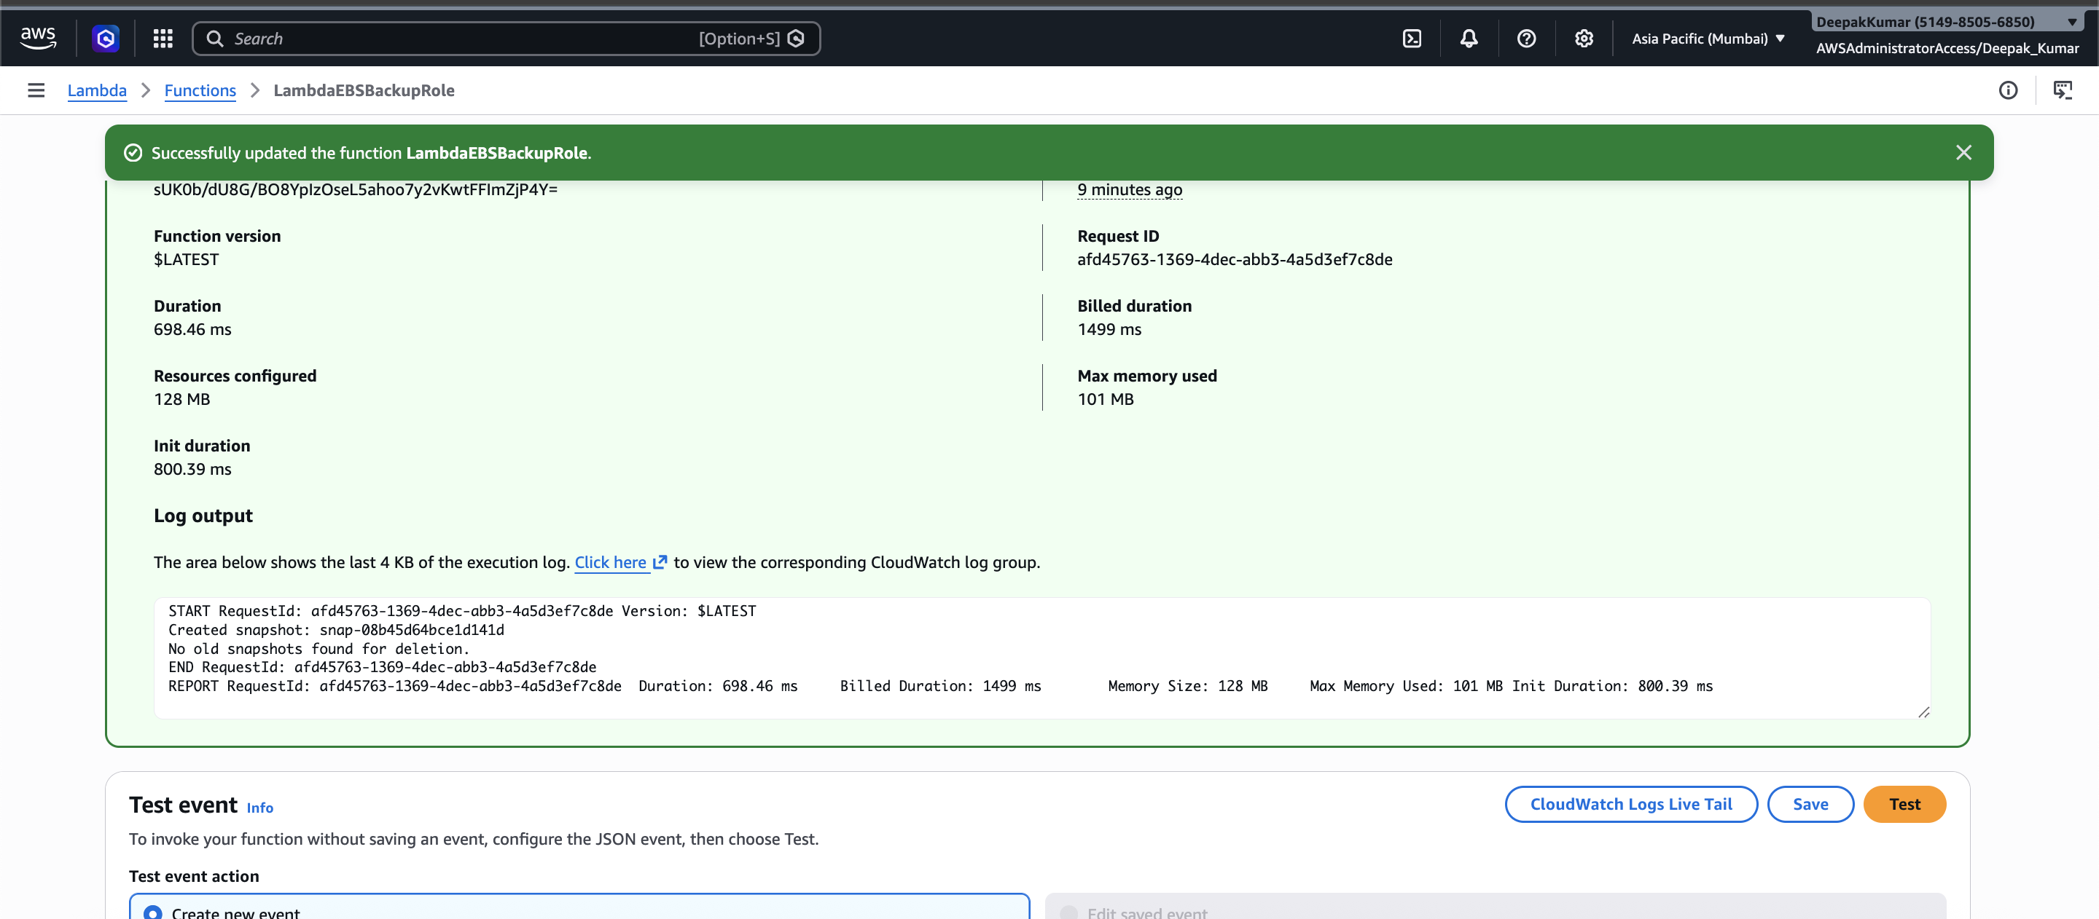

7. Conclusion
This assignment successfully automated the creation and cleanup of EBS snapshots using AWS Lambda and Boto3. The solution created a new snapshot successfully and verified that no snapshots older than 30 days were available for deletion. This demonstrates the practical use of serverless automation for cloud backup management.

